**Source Control Git Option**

**Local Development**

All developers have local repository that they work on, making GIT very fast. Also allows them to test code locally without breaking a shared resource. Each Dev will have:

* Windows IIS
* ColdFusion Developer Edition
* ColdFusion Builder Express w/ eGit Plug-in
* GIT
* Connection to shared database

**Offical Repository Hosting**

Developers after

**Additional Cost $85.00 per month + time to learn**

Git, eGit plugin, ColdFusion Builder Express are all free. A bitbucket.org remote code hosting is $85.00 per month for unlimited users and unlimited repositories. However GIT’s workflow is very different, we will take a short term hit on productivity while people learn how to use the new tools.

**WORKFLOW DIAGRAM**

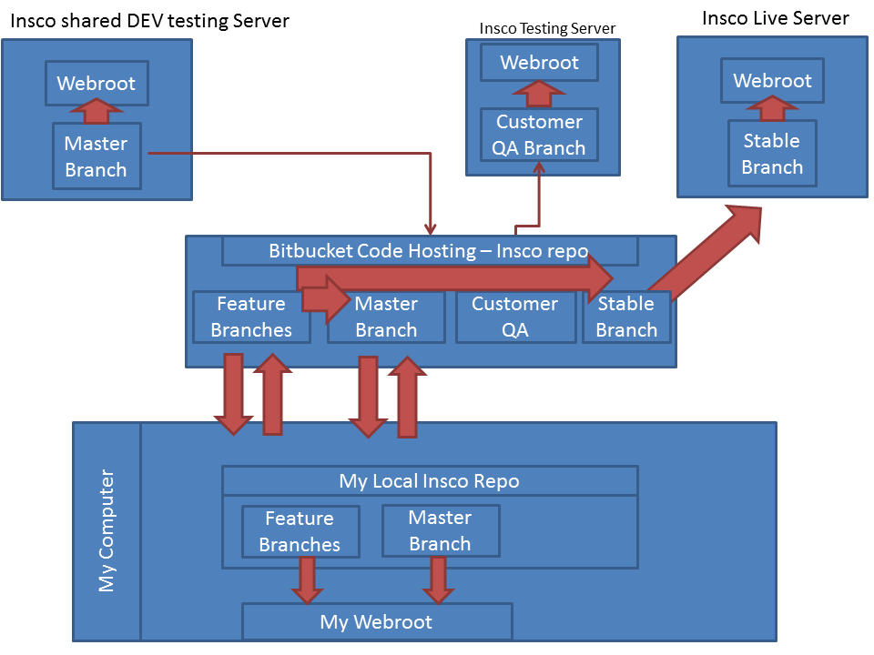

**WORKFLOW DESCRIPTION**

* Larry gets ticket DEV 1593 “Add E-Signature” for customer Insco
* Larry has a local repository named Insco on his computer. He pulls the most recent code down from the private bitbucket copy of the Insco repository. When he pulls he gets the most recent master branch which is code that is considered ready for testing. He also gets copies all other feature branches being worked on the Insco repository. Larry tries his best to keep his local repository updated often, it only takes a few seconds.
* Larry makes a feature branched named “DEV 1593 Adding E-Signature Module” local and also remotely. He tries to make his branch name descriptive as this lets him and others know easily what he working on. When Larry checks out that branch it changes his local web directory to that branches code automatically.
* Larry starts making changes to accomplish his ticket. He only does work relating to DEV1593 on this branch, although he can switch branches almost instantly to work on other tickets if need be. While on Branch DEV1593 git tracks all changes made locally.
* Larry commits to his local branch often and pushes to the remote branch on bitbucket often. (Read: we have offline backup of code in work)
* Larry finishes his work. He has tested it locally on his machine. He has yet to have made any change to the shared Development testing server.
  + (Optional) Larry’s team lead is Moe. Moe likes to review all Larrys work before it is put into the Shared Development Testing Server. Larry thinks his code is ready, so he makes a Pull Request to Moe.
  + (Optional) Moe gets the pull request via bitbuckets interface, it is kind of like Facebook for code. He pulls the bitbucket copy of branch DEV1593 to his local repository. He can either review the code by looking at the changes (by comparing to master) or test out the changes local on his own web server.
  + (Optional) Moe approves of Larry’s changes. So either Larry or Moe or anyone else with a copy of branch DEV1593 can merge these changes with one command.
* Larry merges his changes in to his local copy of master. If there are any merge conflicts he resolves them locally using a graphic merge tool.
* Larry pushes his copy of master to the master branch of bitbucket.
* Larry goes back to step 1
* The DEV Testing Server pulls from the bitbucket Master branch. This can be done by a person or automated. The shared DEV testing server only has a master branch, it is used by QA and/or customer testing.
* Curly is the integration manager. He is the guardian of production code. He has a branch of code in the BitBucket repository for Insco called CustomerQA. He can merge the feature branches that are approved for customer testing, including branch DEV1593 into the customer QA branch and pull those to the shared customer testing server.
* Curly has a branch of code in the bitBucket repository for Insco called Stable Branch. Stable branch is what is current on production. When a branch or ticket is ready for Production he merges all the approved features into the stable branch, resolving any merge conflicts. This branch can be pulled locally for further testing or cycle testing if need be.
* Curly pulls the updated stable branch to the Live server with one command. He can switch back to the prior commit with one command.
* Curly removes the finished ticket Feature branches from the bitBucket repository. Since the code is already part of master and stable branch.